* 0000800000001 *


Cambridge IGCSE™

Ma Qingchuan

FIRST LANGUAGE ENGLISH 0500/11
Paper 1 Reading May/June 2025

2 hours
You must answer on the question paper. You will need: Insert (enclosed)

INSTRUCTIONS
- Answer all questions.
- Use a black or dark blue pen.
- Write your name, centre number and candidate number in the boxes at the top of the page.
- Write your answer to each question in the space provided.
- Do not use an erasable pen or correction fluid.
- Do not write on any bar codes.
- If additional space is needed, you should use the lined pages at the end of this booklet; the question number or numbers must be clearly shown.
- Dictionaries are not allowed.

INFORMATION
- The total mark for this paper is 80.
- The number of marks for each question or part question is shown in brackets [ ].
- The insert contains the reading texts.

This document has 16 pages. Any blank pages are indicated.

DC (CE) 341841/4
© UCLES 2025

[Turn over

* 3 6 8 7 3 9 8 4 8 4 *

DO NOT WRITE IN THIS MARGIN
DO NOT WRITE IN THIS MARGIN
DO NOT WRITE IN THIS MARGIN
DO NOT WRITE IN THIS MARGIN
DO NOT WRITE IN THIS MARGIN
* 0000800000002 *
















2

Read Text A, Treasure Hunting, in the insert and then answer Questions 1(a)–(e) on this question paper.

Question 1

- What two things give people the idea to search for treasure, according to paragraph 1?[1]
Modern-day movies.Classic adventure novels with happy endings.✅
fairytale endings 和 happy endings 是一样的吗？用词要准确，不要自己想当然
- Using your own words, explain what the text means by:

‘… to recover later.’ (lines 6–7)[2]
To come back at a later time and collect the valuable items they had hidden before. ✅

‘… concealed around the globe.’ (line 7)[2]
Hidden in many different places all over the world.✅
其它参考回答：Secreted throughout the world.
- Reread paragraph 3 (‘So, how … of the treasure.’).

Give two different ways treasure hunters should get the information they need to start their search.[2]
Read books and study old maps.Talk to local people who may know about the area.✅
- Reread paragraphs 4 and 5 (‘Treasure hunters … work again.”’).

- Identify two reasons why people who have been inspired to hunt for treasure might not set out straight away.[2]
They need to spend years collecting all the information.They may have to wait until they have enough money to fund the search.✅
- Explain why some people might not be persuaded to take up treasure hunting by Alex Rohn’s claims.[3]
Some people may think his claims are exaggerated because he provides no evidence. He says hunters will always find something, but it may only be a few low-value coins after years of effort. They may also feel that becoming rich enough never to work again is very unlikely.❌ -2

又出现了这类题，文章中并没有直接说，一些人没有被说服去寻宝，而是要从文中的词语表达和事实推出来。
Alex Rohn 说如果你能坚持，早晚能找到宝，即使是一些不值钱的锡罐里的硬币。言外之意，寻宝很花时间，不容易坚持；最终找到了，也可能不值钱；Alex Rohn自己只是个快递员，并没有通过寻宝获得足够财富，从而不用工作，也就是说，他自身没有说服力。
参考答案：
They have to persist hunting, even in the end, the finds maybe just find a few coins. Alex has not been successful enough to give up work.

© UCLES 2025 0500/11/M/J/25

* 0000800000003 *
















3

- Reread paragraph 6 (‘If your heart’s … equipment.’).

Using your own words, explain why now may not be a good time to take up the hobby of treasure hunting.

Although modern equipment is more effective, the remaining treasures are likely to be in places that are difficult to reach. Finding them may require expensive, advanced equipment, making the hobby costly and challenging. The effort involved may discourage many beginners.❌ -2

3分的题回答要回答3个事实，不要说反复说一个事实。

这题有意思，文中说的是现在或许是个好时机去寻宝。但题目问的是，现在可能不是个寻宝的好时机，并让你从文中找出证据。
抵达探宝地点需要大量后勤事务；可能找到之前探宝队没有发现的宝藏，但更有可能一无所获；需要更精良、更昂贵的设备。
参考答案：
Logistics are off-putting, too many people have already looked, treasure left is difficult to find, and it needs expensive equipment.

你知道有哪些著名的寻宝事件吗？
图坦卡蒙
特洛伊
张献中江口沉船

© UCLES 2025
DO NOT WRITE IN THIS MARGIN
DO NOT WRITE IN THIS MARGIN
DO NOT WRITE IN THIS MARGIN
DO NOT WRITE IN THIS MARGIN
DO NOT WRITE IN THIS MARGIN
0500/11/M/J/25
[Turn over

DO NOT WRITE IN THIS MARGIN
DO NOT WRITE IN THIS MARGIN
DO NOT WRITE IN THIS MARGIN
DO NOT WRITE IN THIS MARGIN
DO NOT WRITE IN THIS MARGIN
* 0000800000004 *
















4

Read Text B, Metal detecting, in the insert and answer Question 1(f) on this question paper.

- According to Text B, what concerns, worries and objections might there be about the hobby of metal detecting?

You must use continuous writing (not note form) and use your own words as far as possible.

Your summary should not be more than 120 words.

Up to 10 marks are available for the content of your answer and up to 5 marks for the quality of your writing.

Metal detecting can cause several concerns. It may be illegal in some places because it can be dangerous or damage important historical and cultural sites. Detectorists may also need permits, licences and permission from landowners, while valuable finds must be reported and examined. Archaeologists worry that removing objects from the ground separates them from their original surroundings, causing important historical information to be lost. Since the hobby can be competitive and profitable, some people may be tempted to break the rules. Digging in public areas can also create trip hazards and damage rare or endangered plants. These problems can give metal detecting a negative reputation and make archaeologists want greater restrictions.

Content: 10/10
已涵盖的内容：
Forrest原文 | 得分点
Metal detecting can cause several concerns. | 概括性开头，没有独立得分点
总共只有120 words，每一个词都很宝贵。不过Forrest只写了6个词，也还好。

It may be illegal in some places because it can be dangerous or damage important historical and cultural sites.  ↓  1. It may be illegal in some places  2. because it can be dangerous  3. or damage important historical and cultural site | ↓  1. breaking law(s) / not allowed / illegal  2. safety concerns for detectorists / dangerous to do it  3. damage to historic sites / damage cultural heritage sites
这句话包含了3个得分点，不错

Detectorists may also need permits, licences and permission from landowners, while valuable finds must be reported and examined. | complicated rules / rules vary locally / rules too strict / too many rules
Forrest通过列出：permits、licences、permission from landowners、finds must be reported、finds must、be examined来表现这项活动受到大量规定和手续的限制，也很不错～但是要注意字数

Archaeologists worry that removing objects from the ground separates them from their original surroundings, causing important historical information to be lost. | removing objects from context / losing valuable information
Forrest很好地展现了原文的因果逻辑～
物品脱离原本环境→ 考古背景消失→ 历史信息丢失

Since the hobby can be competitive and profitable, some people may be tempted to break the rules. | competitive by nature so unlikely to follow rules / potential to make lots of money so more likely to bend the rules
Digging in public areas can also create trip hazards and damage rare or endangered plants. | creates trip hazards for others in public spaces
These problems can give metal detecting a negative reputation and make archaeologists want greater restrictions. | 1. negative image of the hobby / seen as boring / waste of time  2. restrictions not strong enough / restrictions should be stronger

未涵盖的点：
1. Some detectorists irresponsible
2. Increase in popularity / TV influence

Writing：5/5
concision + organisation + own words + clarity + grammatical accuracy
整体paraphrase做得很好，能按照题目的“use your own words”以及“not be more than 120 words”

© UCLES 2025 0500/11/M/J/25

* 0000800000006 *
















6

Read Text C, The beach, in the insert and then answer Questions 2(a)–(d) on this question paper.

Question 2

- Identify a word or phrase from the text which suggests the same idea as the words underlined:

  - The boys and their mother have to pass through and around the delicate hills of sand to get access to the beach.

weave between[1] ✅

  - The goods carried by the ship that sank were never found, but the people on board were saved.

its crew was rescued[1] ✅

  - It is not unusual for the narrator to discover everyday items that have been thrown away without thought on the beach.

carelessly discarded[1] ✅

  - Previously, vehicles were allowed on the beach.

permitted[1] ✅

- Using your own words, explain what the writer means by each of the words underlined:

On this dazzling afternoon, cycling along the sea’s edge is exhilarating and our laughter sends seagulls scattering skywards. The new path we’re following ends abruptly and we’re stranded on the wrong side of a channel of water.

  - dazzling:Very bright and sunny.[1] ✅

  - exhilarating:Making us feel excited and full of energy.[1] ✅

  - abruptly:Suddenly and without warning.[1] ✅

© UCLES 2025 0500/11/M/J/25

* 0000800000007 *
















7

- Use one example from the text below to explain how the writer suggests her feelings as she attempts to cross the channel of water on her bicycle.

Use your own words in your explanation.

I show the boys that, like life, if you approach it full on, you can most times power through on sheer determination. But today the channel’s deeper than it looks. I’ve misjudged it massively. My bike comes to a graceless halt midway, balances briefly, then falls flat on its side, depositing me spectacularly in fifty centimetres of water.

The writer suggests that she feels confident at first but then embarrassed and surprised when she attempts to cross the channel. She says she approaches it “full on” and relies on “sheer determination”, showing that she is confident in her ability to overcome the obstacle. However, she admits that she has “misjudged it massively”, showing that she suddenly realises she has made a serious mistake. The description of her bicycle making a “graceless halt” and falling into the water also creates a humorous image of her failed attempt. This suggests that although she is embarrassed by what happened, she can laugh at herself and does not take the accident too seriously.

3/3
评分标准：Award 3 marks for an appropriate example with a comprehensive explanation which shows understanding of how the writer suggests her feelings...
拿满分需要：
1. 合适的原文例子 + 比较完整的解释 + 真正理解作者的感受是怎样被语言表现出来的。
2. The explanation must be predominantly in the candidate’s own words. (Forrest做得很好)

点评：
Forrest原文 | 得分点
The writer suggests that she feels confident at first but then embarrassed and surprised when she attempts to cross the channel. | *optimism / self-belief  *surprise  *sudden realisation  *slightly embarrassed  *sees the humour
She says she approaches it “full on” and relies on “sheer determination”, showing that she is confident in her ability to overcome the obstacle. | self-belief / optimism
Forrest还可以分析得更深。Forrest可能没注意到原文的“like life”
作者不只是说“我要骑过去”，而是把骑过水道和面对人生困难联系起来：if you approach it full on, you can most times power through on sheer determination
另外，作者不只是普通的confident，而是有点overconfident。后面的失败正好打脸，所以反差特别明显～不会影响Forrest拿分，只不过想引导一下Forrest的思考深度
However, she admits that she has “misjudged it massively”, showing that she suddenly realises she has made a serious mistake. | *made an error  *hugely underestimated  *got it completely wrong  *serious  *surprise  *sudden realisation  *may have been overconfident
Forrest没有把“misjudged”原封不动换一个词就结束，而是解释出了：
她意识到自己之前判断错了。

The description of her bicycle making a “graceless halt”and falling into the water also creates a humorous image of her failed attempt. | *inelegant stop  *realises she looks silly  *self-deprecating  *sees the humour in the moment
This suggests that although she is embarrassed by what happened, she can laugh at herself and does not take the accident too seriously. | *self-deprecating  *sees the humour in the moment  *hilarious  *harmless fun

比较严重的问题：题目说Use one example，Forrest用了三个！
① full on/sheer determination
②misjudged it massively
③graceless halt

Forrest应该选一个例子，把这个例子讲透
而不是选三个例子，每个分析一点点

改过的：

The writer suggests that she feels very confident and optimistic as she attempts to cross the channel. The phrase “full on” suggests that she tackles the obstacle with great confidence and does not hesitate. It shows that she strongly believes she can succeed through her own effort. The earlier comparison to life also suggests that she sees difficulties as something that can be overcome by facing them directly, although this may show that she is slightly overconfident. This makes her later failure particularly surprising.

DO NOT WRITE IN THIS MARGIN
DO NOT WRITE IN THIS MARGIN
DO NOT WRITE IN THIS MARGIN
DO NOT WRITE IN THIS MARGIN
DO NOT WRITE IN THIS MARGIN
© UCLES 2025

0500/11/M/J/25

[Turn over

DO NOT WRITE IN THIS MARGIN
DO NOT WRITE IN THIS MARGIN
DO NOT WRITE IN THIS MARGIN
DO NOT WRITE IN THIS MARGIN
DO NOT WRITE IN THIS MARGIN
* 0000800000008 *
















8

- Reread paragraphs 3 and 7.

- Paragraph 3 begins ‘From this distance … ’ and is about the wreck.
- Paragraph 7 begins ‘Treasure hunting … ’ and is about the egg cases of fish.

Explain how the writer uses language to convey meaning and to create effect in these paragraphs. Choose three examples of words or phrases from each paragraph to support your answer. Your choices should include the use of imagery.

Write about 200 to 300 words.

Up to 15 marks are available for the content of your answer.

In paragraph 3, the writer uses vivid imagery to show how surprising and exciting the shipwreck is. The phrase “looks unreal, like some elaborate prop on a sweeping stage of sand” is a simile which makes the wreck seem like part of a dramatic performance rather than a real object. This shows how amazed the writer is by its unexpected appearance. The description “curved wooden spurs like the ribcage of some enormous extinct beast” is another striking simile. Comparing the ship to the skeleton of a huge animal makes it seem ancient, mysterious and almost frightening. The verb “picked clean” suggests that the sea has stripped away everything except the ship’s remains, emphasising its damaged and abandoned condition.
In paragraph 7, the writer uses descriptive language to make the skate egg case seem delicate and fascinating. The phrase “soft in texture, olive brown and translucent” uses detailed sensory description, allowing the reader to imagine its unusual appearance. The expression “holding it to the light” shows the writer’s careful and curious attitude towards the object. Finally, the phrase “a fragile promise for the future” is a metaphor which presents the baby skate as a symbol of new life and hope. The adjective “fragile” also emphasises how vulnerable the tiny creature is. Overall, both paragraphs use vivid imagery to show the writer’s sense of wonder at the unexpected things revealed by the beach.

11/15
Paragraph 3：
例子1: looks unreal, like some elaborate prop on a sweeping stage of sand
Forrest原文 | 得分点
part of a dramatic performance rather than a real object | make-believe ship / object prepared for a play or film / grand theatrical scenery
这一个例子选得很好。Forrest能认得出来这是simile，并且看出了“舞台道具”的感觉。但是，Forrest还可以分析得更细
目前主要分析了“像舞台道具”，但是忽略了unreal / elaborate / sweeping。
*unreal：说明作者几乎难以相信眼前看到的东西是真的，突出沉船突然出现时的震撼和不真实感。
*elaborate prop：不是普通的 prop，而是“精心制作、复杂的道具”，让沉船显得非常戏剧化、视觉上很夸张。
*sweeping stage of sand：把整片广阔沙滩想象成一个巨大的舞台，增强了场景规模感

Forrest可以参考这个步骤：具体词 → 联想 → 画面 → effect

例子2: curved wooden spurs like the ribcage of some enormous extinct beast
Forrest原文 | 得分点
Comparing the ship to the skeleton of a huge animal makes it seem ancient, mysterious and almost frightening. | ancient / exposed bones / skeleton of a large sea creature or dinosaur
Forrest直接从整个比喻跳到了效果，中间缺少“为什么”（这和写article的不严谨思路也很像哦）
有很多细节可以分析：
*ribcage：让船架看起来像裸露的骨头，带出死亡、腐朽、残骸感
*enormous：强调体积巨大，让沉船更震撼
*extinct：让它像来自遥远过去，增强古老感
*beast：比一般的动物更野性、更可怕，增加威胁感
因此，Forrest说“ancient, mysterious and almost frightening”没错，但如果不解释这些感觉是由哪些具体词产生的，就还没到最细致的语言分析。

例子3: picked clean
Forrest原文 | 得分点
the sea has stripped away everything except the ship’s remains, emphasising its damaged and abandoned condition. | “picked clean of its flesh by the sea”: nothing left of the external fittings of the ship; sea has eaten it alive; predatory power of oceans/nature
Forrest理解了picked clean的基本意思，知道这是在说大海把船上原本的东西“剥掉、弄走”，只剩残骸，这个思路不是错。但是，这只是分析到了得分点的第一层：nothing left of the external fittings of the ship，主要停留在字面意思
真正要深入分析的是“picked clean of its flesh by the sea”。它和前面的：ribcage、beast、flesh共同建立了一个非常清楚的“动物形象”：沉船像一具被啃食过的动物尸体，大海像把它吃得只剩骨头的捕食者。所以，Forrest的分析还是有点太普通了，没有抓到这个意象最有力量的地方。

参考逻辑：
*ship = dead creature
*sea = predator/scavenger
*effect = nature seems powerful, destructive, almost violent

Paragraph 7：
例子1: soft in texture, olive brown and translucent
Forrest原文 | 得分点
The phrase “soft in texture, olive brown and translucent” uses detailed sensory description, allowing the reader to imagine its unusual appearance. | freshly cast, and quite different: soft in texture, olive brown and translucent”  newly made; inviting the children to touch it; contrast of still moist, smooth and almost see through; can just see the secret inside
Forrest的这句分析比较泛。“allowing the reader to imagine its unusual appearance”几乎可以放在任何外貌描写后面，所以还不够有针对性。

Forrest的重点应该放在：
*soft in texture：和前面的 desiccated, blackened and hardened 形成对比，说明这个卵囊很新鲜，不是干枯死掉的
*olive brown：颜色自然、有机，让它显得像真实的海洋生命体
*translucent：半透明，不是完全透明，所以里面的东西若隐若现，增强神秘感和好奇心

例子2: holding it to the light
The expression “holding it to the light” shows the writer’s careful and curious attitude towards the object. | I pick it up carefully, holding it to the light for observation: gently lifts it from the sand so they can look at it; trying not to harm it; scientific interest
Forrest可以更加深入分析：作者不是随便拿起来看，而是举到光下观察，说明她对这个卵囊很认真、很珍惜，也像在研究一个珍贵的自然标本。“careful and curious attitude”也有点太简单了，概括性太强，不是深入的分析。

例子3: a fragile promise for the future
Finally, the phrase “a fragile promise for the future” is a metaphor which presents the baby skate as a symbol of new life and hope. The adjective “fragile” also emphasises how vulnerable the tiny creature is. | tiny baby skate, a fragile promise for the future, almost ready to hatch: the purse holds a small, delicate creature; vulnerable baby fish will grow up to keep the species alive, comparison to Charlie; need/hope to protect the environment
Forrest不只是识别了metaphor，还解释出了象征意义：这个小鳐鱼象征新生命和希望～
Forrest真正做到了深入分析一个词。“fragile”不只是说明它小，而是强调它很容易受到伤害、需要被保护。
但是“promise”不只是“未来”，而是一种，未来会有美好事情发生的希望或可能性。因此，Forrest还可以深入分析：正因为这个“promise”很fragile，所以作者的希望并不是轻松、绝对的，而是带着一种需要保护环境、保护生命的责任感。

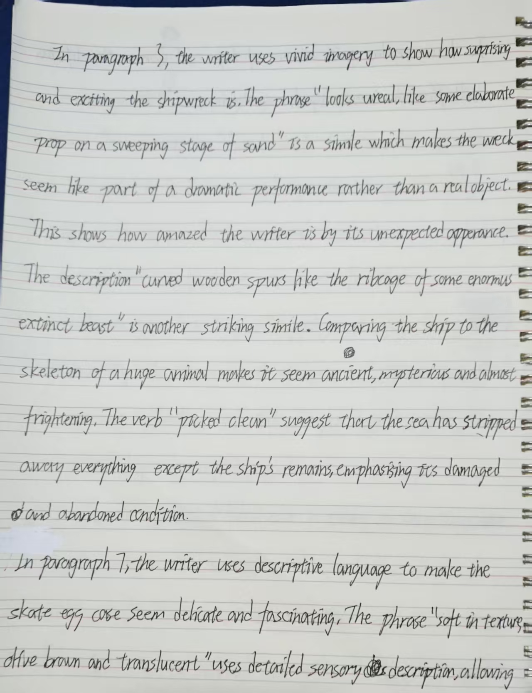

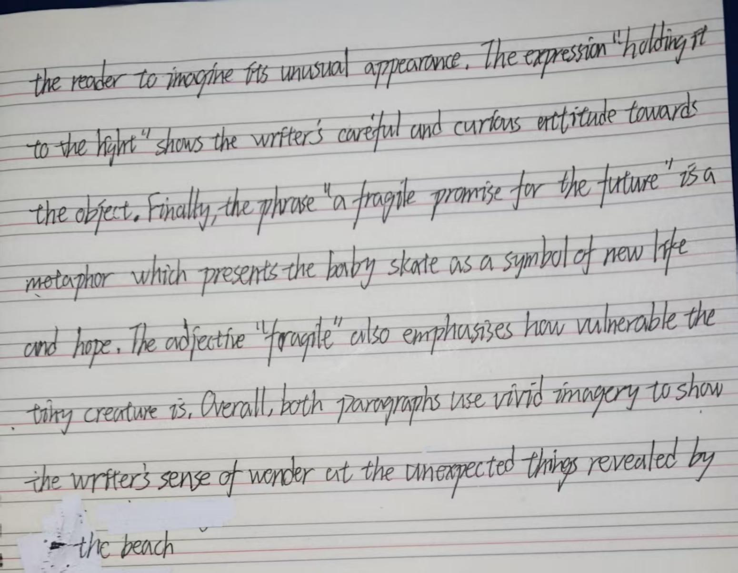

© UCLES 2025 0500/11/M/J/25

* 0000800000009 *
















10

Reread Text C, The beach, in the insert and then answer Question 3 on this question paper. Question 3
You are Charlie. Years later you work for an organisation which protects natural environments. As part of your work, you give a speech to persuade young people to protect your local area.

In your speech you:

- describe how you spent your afternoons on the beach as a young boy and what you enjoyed best about those activities looking back
- explain what you learned from your mother about the beach, its history and its people
- suggest how and why you were inspired to protect natural environments and what you think young people can do to help this beach.

Write the words of the speech.

Base your speech on what you have read in Text C, but be careful to use your own words. Address each of the three bullets.

Write about 250 to 350 words.

Up to 15 marks are available for the content of your answer and up to 10 marks for the quality of your writing.

..........................................................................................................................................................

..........................................................................................................................................................

..........................................................................................................................................................

..........................................................................................................................................................

..........................................................................................................................................................

..........................................................................................................................................................

..........................................................................................................................................................

..........................................................................................................................................................

..........................................................................................................................................................

..........................................................................................................................................................

..........................................................................................................................................................

..........................................................................................................................................................

..........................................................................................................................................................

..........................................................................................................................................................

..........................................................................................................................................................

..........................................................................................................................................................

© UCLES 2025 0500/11/M/J/25

DO NOT WRITE IN THIS MARGIN
DO NOT WRITE IN THIS MARGIN
DO NOT WRITE IN THIS MARGIN
DO NOT WRITE IN THIS MARGIN
DO NOT WRITE IN THIS MARGIN
* 0000800000011 *
















11

..........................................................................................................................................................

..........................................................................................................................................................

..........................................................................................................................................................

..........................................................................................................................................................

..........................................................................................................................................................

..........................................................................................................................................................

..........................................................................................................................................................

..........................................................................................................................................................

..........................................................................................................................................................

..........................................................................................................................................................

..........................................................................................................................................................

..........................................................................................................................................................

..........................................................................................................................................................

..........................................................................................................................................................

..........................................................................................................................................................

..........................................................................................................................................................

..........................................................................................................................................................

..........................................................................................................................................................

..........................................................................................................................................................

..........................................................................................................................................................

..........................................................................................................................................................

..........................................................................................................................................................

..........................................................................................................................................................

..........................................................................................................................................................

..........................................................................................................................................................

..........................................................................................................................................................

. [25]

[Total: 25]

© UCLES 2025 0500/11/M/J/25

DO NOT WRITE IN THIS MARGIN
DO NOT WRITE IN THIS MARGIN
DO NOT WRITE IN THIS MARGIN
DO NOT WRITE IN THIS MARGIN
DO NOT WRITE IN THIS MARGIN
* 0000800000012 *
















12

Additional page

If you use the following page to complete the answer to any question, the question number must be clearly shown.

..................................................................................................................................................................

..................................................................................................................................................................

..................................................................................................................................................................

..................................................................................................................................................................

..................................................................................................................................................................

..................................................................................................................................................................

..................................................................................................................................................................

..................................................................................................................................................................

..................................................................................................................................................................

..................................................................................................................................................................

..................................................................................................................................................................

..................................................................................................................................................................

..................................................................................................................................................................

..................................................................................................................................................................

..................................................................................................................................................................

..................................................................................................................................................................

..................................................................................................................................................................

..................................................................................................................................................................

..................................................................................................................................................................

..................................................................................................................................................................

..................................................................................................................................................................

..................................................................................................................................................................

..................................................................................................................................................................

..................................................................................................................................................................

..................................................................................................................................................................

..................................................................................................................................................................

© UCLES 2025 0500/11/M/J/25

DO NOT WRITE IN THIS MARGIN
DO NOT WRITE IN THIS MARGIN
DO NOT WRITE IN THIS MARGIN
DO NOT WRITE IN THIS MARGIN
DO NOT WRITE IN THIS MARGIN
* 0000800000013 *
















13

Additional page

If you use the following page to complete the answer to any question, the question number must be clearly shown.

..................................................................................................................................................................

..................................................................................................................................................................

..................................................................................................................................................................

..................................................................................................................................................................

..................................................................................................................................................................

..................................................................................................................................................................

..................................................................................................................................................................

..................................................................................................................................................................

..................................................................................................................................................................

..................................................................................................................................................................

..................................................................................................................................................................

..................................................................................................................................................................

..................................................................................................................................................................

..................................................................................................................................................................

..................................................................................................................................................................

..................................................................................................................................................................

..................................................................................................................................................................

..................................................................................................................................................................

..................................................................................................................................................................

..................................................................................................................................................................

..................................................................................................................................................................

..................................................................................................................................................................

..................................................................................................................................................................

..................................................................................................................................................................

..................................................................................................................................................................

..................................................................................................................................................................

© UCLES 2025 0500/11/M/J/25

DO NOT WRITE IN THIS MARGIN
DO NOT WRITE IN THIS MARGIN
DO NOT WRITE IN THIS MARGIN
DO NOT WRITE IN THIS MARGIN
DO NOT WRITE IN THIS MARGIN
* 0000800000014 *
















14

BLANK PAGE

© UCLES 2025 0500/11/M/J/25

DO NOT WRITE IN THIS MARGIN
DO NOT WRITE IN THIS MARGIN
DO NOT WRITE IN THIS MARGIN
DO NOT WRITE IN THIS MARGIN
DO NOT WRITE IN THIS MARGIN
* 0000800000015 *
















15

BLANK PAGE

© UCLES 2025 0500/11/M/J/25

DO NOT WRITE IN THIS MARGIN
DO NOT WRITE IN THIS MARGIN
DO NOT WRITE IN THIS MARGIN
DO NOT WRITE IN THIS MARGIN
DO NOT WRITE IN THIS MARGIN
* 0000800000016 *
















16

BLANK PAGE

Permission to reproduce items where third-party owned material protected by copyright is included has been sought and cleared where possible. Every reasonable effort has been made by the publisher (UCLES) to trace copyright holders, but if any items requiring clearance have unwittingly been included, the publisher will be pleased to make amends at the earliest possible opportunity.

To avoid the issue of disclosure of answer-related information to candidates, all copyright acknowledgements are reproduced online in the Cambridge Assessment International Education Copyright Acknowledgements Booklet. This is produced for each series of examinations and is freely available to download at www.cambridgeinternational.org after the live examination series.

Cambridge Assessment International Education is part of Cambridge Assessment. Cambridge Assessment is the brand name of the University of Cambridge Local Examinations Syndicate (UCLES), which is a department of the University of Cambridge.

© UCLES 2025 0500/11/M/J/25

